10.0 Entity Relationship Diagram (ERD)
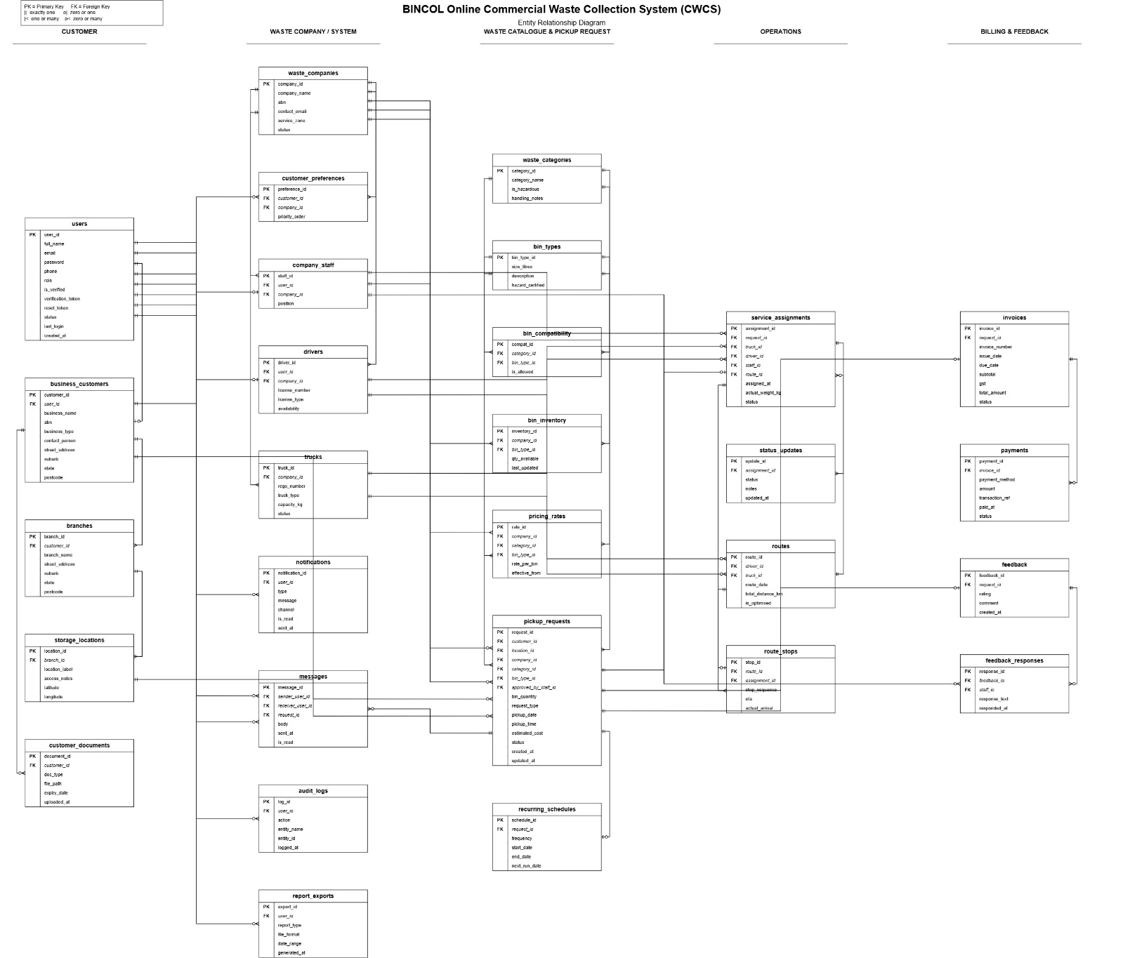
10.0 Entity Relationship Diagram (ERD)
This section presents the Entity Relationship Diagram (ERD) for the BINCOL Online Commercial Waste Collection System. The ERD provides a visual representation of the database structure, showing all entities (tables), their attributes (fields), and the relationships between them. This diagram serves as the foundation for the database design and implementation, ensuring that all system data is properly organised, stored, and accessed.
The ERD follows the implementation-level design, meaning it includes all necessary details for actual database creation, including primary keys, foreign keys, and participation constraints. The diagram is structured using crow's foot notation, which clearly shows the cardinality and optionality of relationships between entities (1:1, 1:M, and M:M).

Key Entities and Modules
Module | Entities Included
User Management | users, business_customers, branches, storage_locations
Waste Catalogue & Pickup | pickup_requests, recurring_schedules, service_assignments
Payment & Billing | invoices, payments
Driver & Route Management | drivers, trucks, routes
Notifications | notifications
Feedback | feedback, feedback_responses
Audit & Reporting | audit_logs, reports

Entity Descriptions
Entity | Description
users | Stores login credentials, password (hashed), role, verification status, and account status
business_customers | Stores customer business details — business name, ABN, contact person, address
branches | Multiple business locations under one customer account
storage_locations | Waste storage points on site — bin placement, access notes, GPS coordinates
pickup_requests | Core booking record — pickup date/time, waste type, bin size, cost, status
recurring_schedules | Recurring pickup rules — frequency, start/end dates, next run date
service_assignments | Links bookings to drivers and trucks — assignment timestamp, status
invoices | Billing records — amount, status (unpaid/paid/overdue), generated date
payments | Transaction records — payment method, amount, reference, status
notifications | User notifications — type, channel (email/dashboard), read status
feedback | Customer ratings and comments on completed services
feedback_responses | Staff responses to customer feedback
audit_logs | System activity log for compliance and security auditing
reports | Generated reports — type, frequency, file path, export format

Relationships
Relationship | Type
users → business_customers | 1:1
business_customers → branches | 1:M
branches → storage_locations | 1:M
users → pickup_requests | 1:M
pickup_requests → recurring_schedules | 1:1
pickup_requests → service_assignments | 1:1
pickup_requests → invoices | 1:1
invoices → payments | 1:M
users → notifications | 1:M
pickup_requests → feedback | 1:1
feedback → feedback_responses | 1:1
users → audit_logs | 1:M

Participation Constraints
Entity | Participation
users ↔ business_customers | Mandatory on both sides (1:1)
business_customers ↔ branches | Mandatory on customer side, optional on branch side (1:M)
users ↔ pickup_requests | Mandatory on user side, mandatory on request side (1:M)
pickup_requests ↔ invoices | Mandatory on both sides (1:1)

